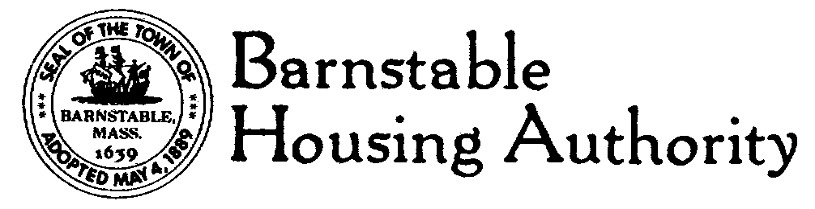
Telephone 508.771.7222
FAX: 508.778.9312
TDD / TTY: 508-778-5333
146 South Street • Hyannis, MA 02601

Request for Quotes

Barnstable Housing Authority window replacement project
71 Maple Street, Hyannis

Barnstable Housing Authority is seeking quotes from licensed and insured contractors to supply and install thirteen (13) Low E/Argon double lock, full screen, aluminum replacement windows in an occupied two story single family home in Hyannis. Ten (10) windows are double hung; three (3) windows are casement. Barnstable Housing Authority (BHA) prefers Stergis EnerG window but will consider equivalent manufacturers. This is a drywall return application.

Contractor must make special effort to accommodate the aluminum siding on the rear and sides of the house and the composite siding on front of the house. Massachusetts prevailing wage rates shall apply to this job. There is a site visit scheduled for Thursday, May 28th at 9:30 a.m. Interested parties should meet the BHA representative on the job site.

Please do not attempt to visit the site at any time without a BHA representative. Written quotes shall be submitted no later than June 10th at 2 p.m. Quotes shall include an anticipated lead time for completion of the job. All quotes shall be submitted to the Barnstable Housing Authority, 146 South Street, Hyannis, MA 02601 508.771.7222

BHA is an Equal Opportunity Employer

