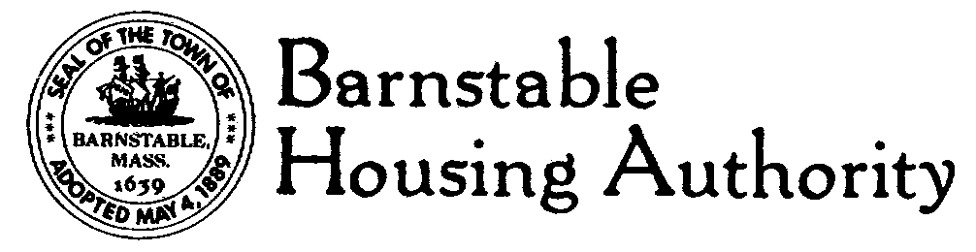
Telephone 508.771.7222
FAX: 508.778.9312
TDD / TTY: 508-778-5333
146 South Street • Hyannis, MA 02601

93 Pleasant Street Trim Painting and Gutter Cleaning project

Aunt Sarah’s Harborview House at 93 Pleasant Street, Hyannis, MA is multi-level, fully occupied home located within the Town of Barnstable’s Historic Waterfront District. Due to the locus of the building, there shall be no deviations from the prepared and supplied Scope of Work.

Interested contractors may view the work site any time between 8 a.m. and 4 p.m., Monday through Saturday. Entry into the building is not necessary as this is an exterior project. Parking for the building is accessed via South Street only.

Please note this project has both State of Massachusetts and Federal funding, therefore all persons wishing to quote must review both Davis-Bacon and Prevailing wages and utilize whichever rate is higher for pricing purposes. Copies of both wage rates are available at the front desk of Barnstable Housing Authority, 146 South Street, Hyannis. The BHA is open from 8 a.m. to 4 p.m., Monday through Friday.

Written quotes on letterhead must be submitted to the Barnstable Housing Authority no later than 2 p.m. on Monday, August 5th.

Published on website: barnstablehousing.org
7/19/2013

