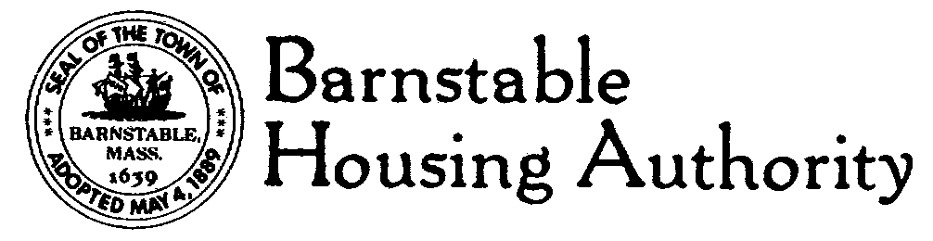
Snow Removal Proposal/Bid form for Winter Season 2022-2023

Snow shall be removed any time as requested by the Barnstable Housing Authority (BHA), but will automatically occur after accumulation of three (3”) inches on walkways. Walkways and roadways must be regularly monitored for safety purposes and must be kept clear of snow as per above. Contractor shall provide and spread bio-friendly ice melt and or sand as needed, and must not wait until snowfall ceases to begin work. Contractor shall submit written documentation of time of plow/shovel and approximate temperature and conditions per property visit. (May include directly on invoice.)

Payments for services rendered shall be made after monthly Board of Commissioner’s meeting. Contractor shall provide a current W-9 and proof of liability insurance prior to beginning work.

ADDRESS 3” to 5” 5” to 8” Over 8”

32-54 Sea Street Ext., Hyannis

200 Stevens Street

71 Pleasant Street

70 Stage Coach Rd., Centerville

Additional services available and rate:

Extra sanding?
Bobcat services?

Please submit best prices as described above. Clearly list contact information. ALL BIDS MUST BE SUBMITTED by 1PM, November 28, 2022 to Barnstable Housing Authority, 146 South Street, Hyannis, MA 02601, marked SNOW REMOVAL.

The BHA does not shovel out individual vehicles. Parking areas and all walkways must be kept free and clear of snow and debris to allow passageway for emergency vehicles.
EOE

